CS3180
Homework 2
Todd Carter
V01187982

Section 3.1:

2) Find all strings in L(ab + b)*b(a + ab)*) of length less than 4.

Len 0 | b | Len 0 | b
Len 0 | b | Len 1 | ba
Len 0 | b | Len 0 | baa | bab
Len 1 | b | Len 1 | bb
Len 1 | b | Len 0 | bba
Len 1 | b | Len 1 | abb | bbb

All strings are: b, ba, baa, bab, bb, bba, abb, and bbb.

3) Find an NFA that accepts the language L(aa*(ab + b)).

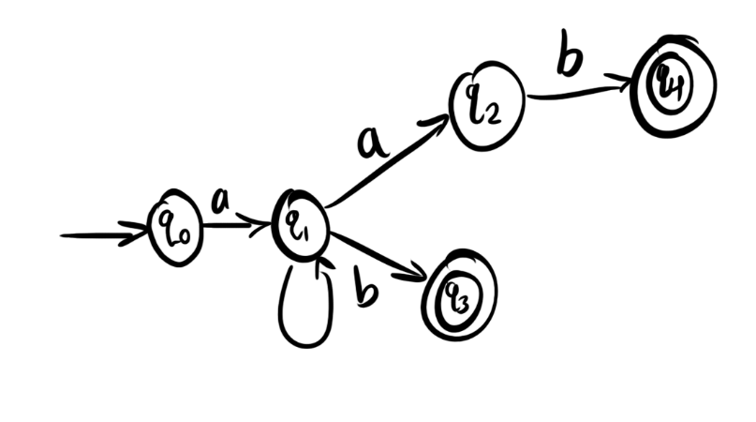

8) Find a regular expression for the set {a^n b^m : (n + m) is odd}.

a(aa)*(bb)* + (aa)*b(bb)*

9) Give regular expressions for the following languages:
a) L1 = {a^{n}b^{m} , n >= 3, m <= 4}

aaaa*(λ + b + bb + bbb)

c) The complement of L1.

{strings that contain ba} U {too few a’s} U {too many b’s}

(a + b)*ba(a + b)* + (λ + a + aa)b* + a*bbbbbb*

14) Find a regular expression for L = {ab^{n} w : n >= 4, w ϵ {a, b} + }.

abbbbb*(a + b)⁺

18) Find a regular expression for L = {w ϵ {0, 1}* : w has exactly one pair of consecutive zeros.}

(1 + 01)*00(1 + 10)*

Section 3.2:

3) Use the construction in Theorem 3.1 to find an NFA that accepts the language
L(ab*aa + bba*ab).
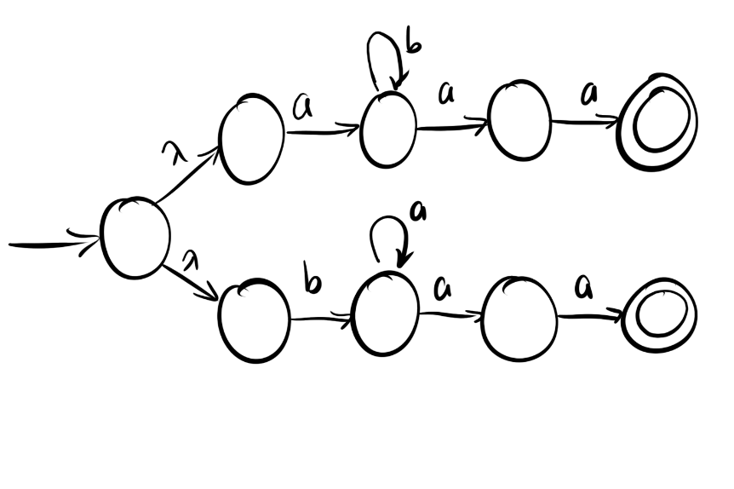

4) Find an NFA for the complement of the language in exercise 3.

Don’t have to do this one?

12) Find regular expressions for the languages accepted by the following DFAs.
a)
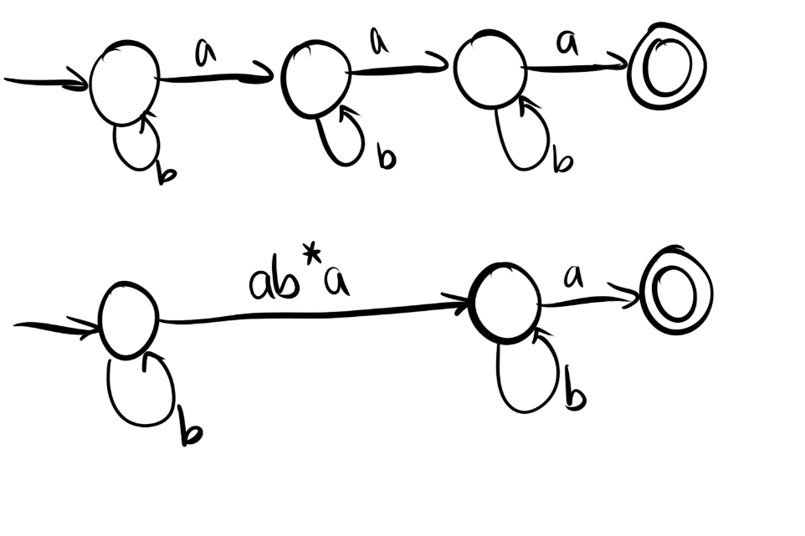
Regular expression:
L(M) = b*ab*ab*a

b)
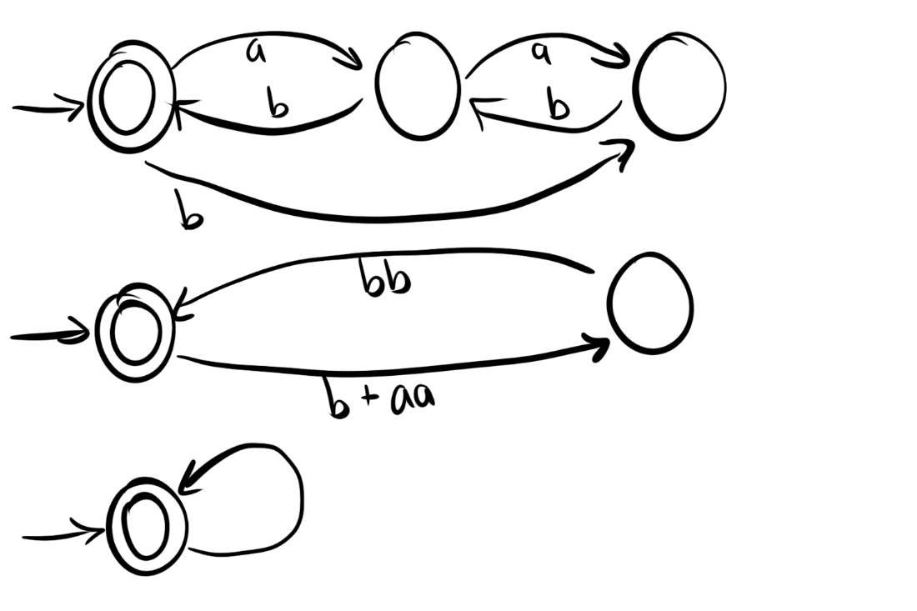
Regular expression:
L(M) = (b + aa)(bb)
15) Find a regular expression for the following languages:
a) L = {w : n_{a}(w) and n_{b}(w) are both odd}

L(M) = (aa)*a((bb)*b) + (bb)*b(aa*)a)

